**A PERSONALIZED TRAVEL PLANNING AND TRACKING APP**

**Team Members:**

**RAMKUMAR.P : E4EFB42A8C04097BDA9437CC0BBE2566**

**RAJESH.R : B6C0C7201A7EFB197BD414EBC3AC0BE8**

**LOGESWARAN.V : 0824738CABEF658A113413712EA13671**

**ARUNKUMAR.N : 494F2059A602104B5BC4B29AE8A83D21**

**MODULE 1:**

**DOWNLOAD ANDROID STUDIO**:

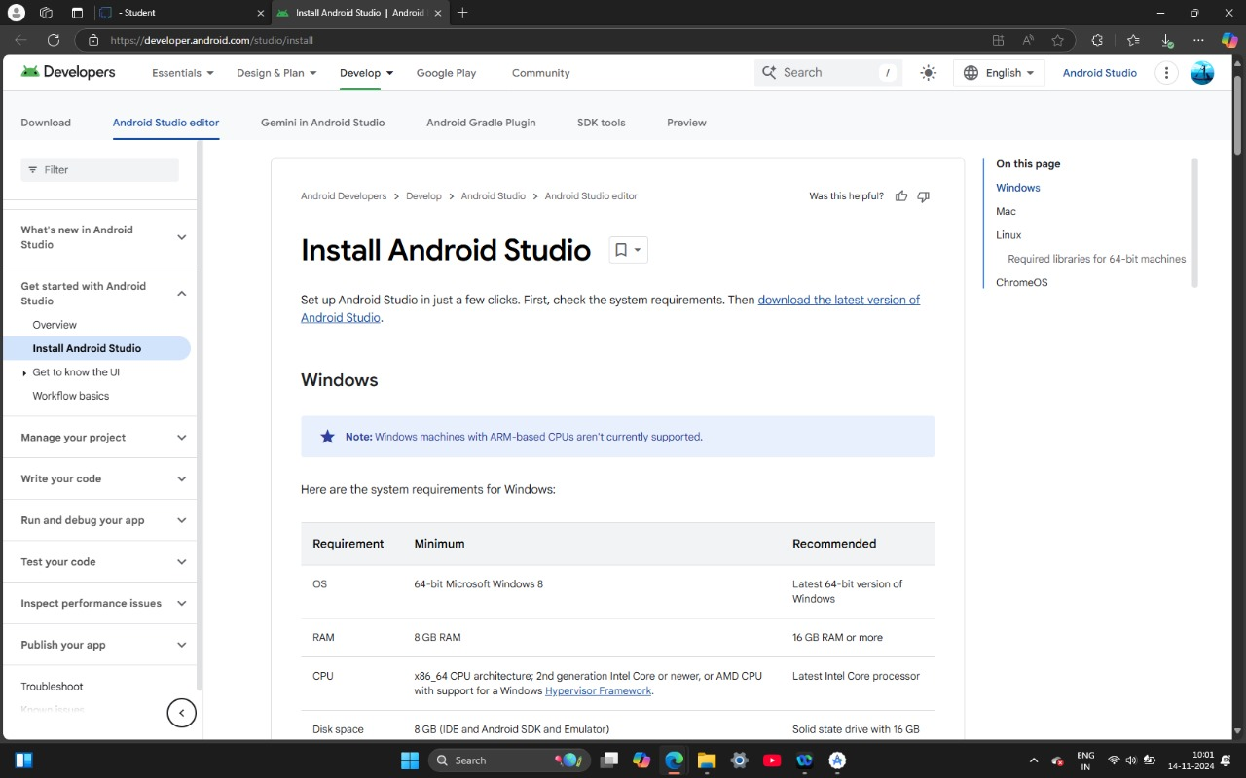

**INSTALLING ANDROID STUDIO** :

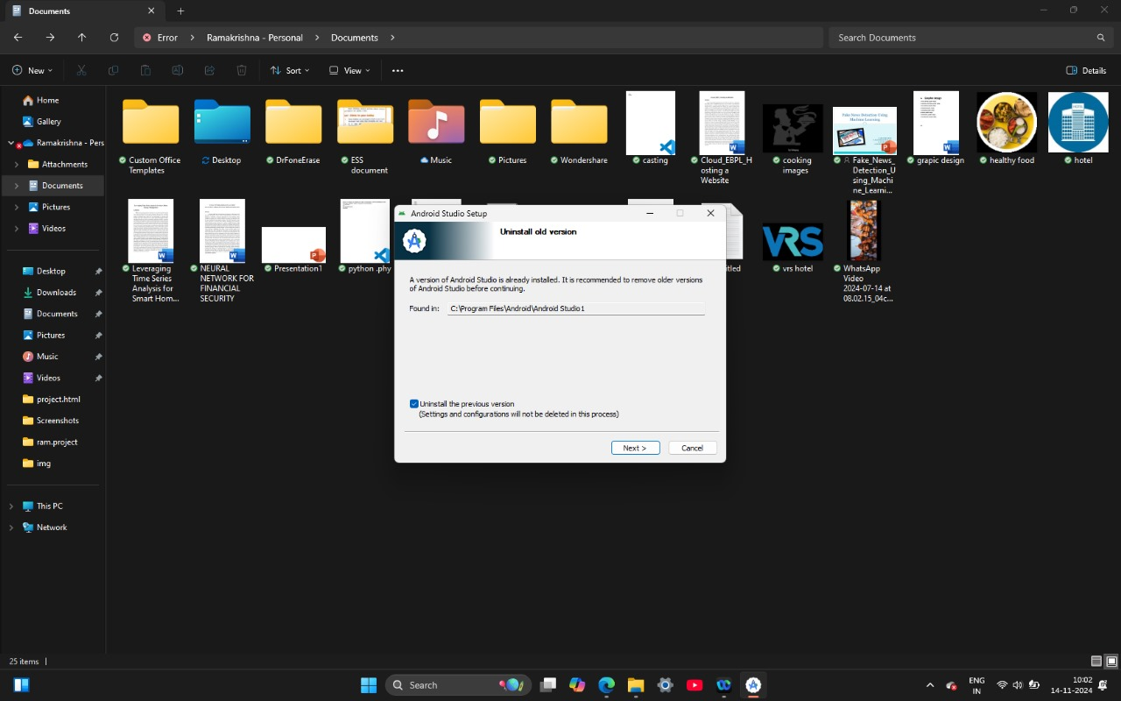

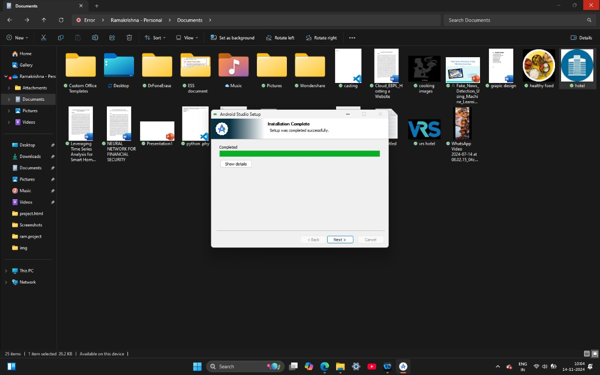

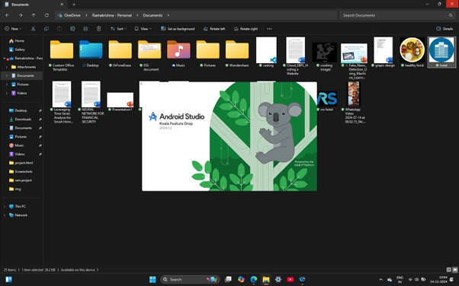

**CREATE NEW PROJECT :**

**Step :1**

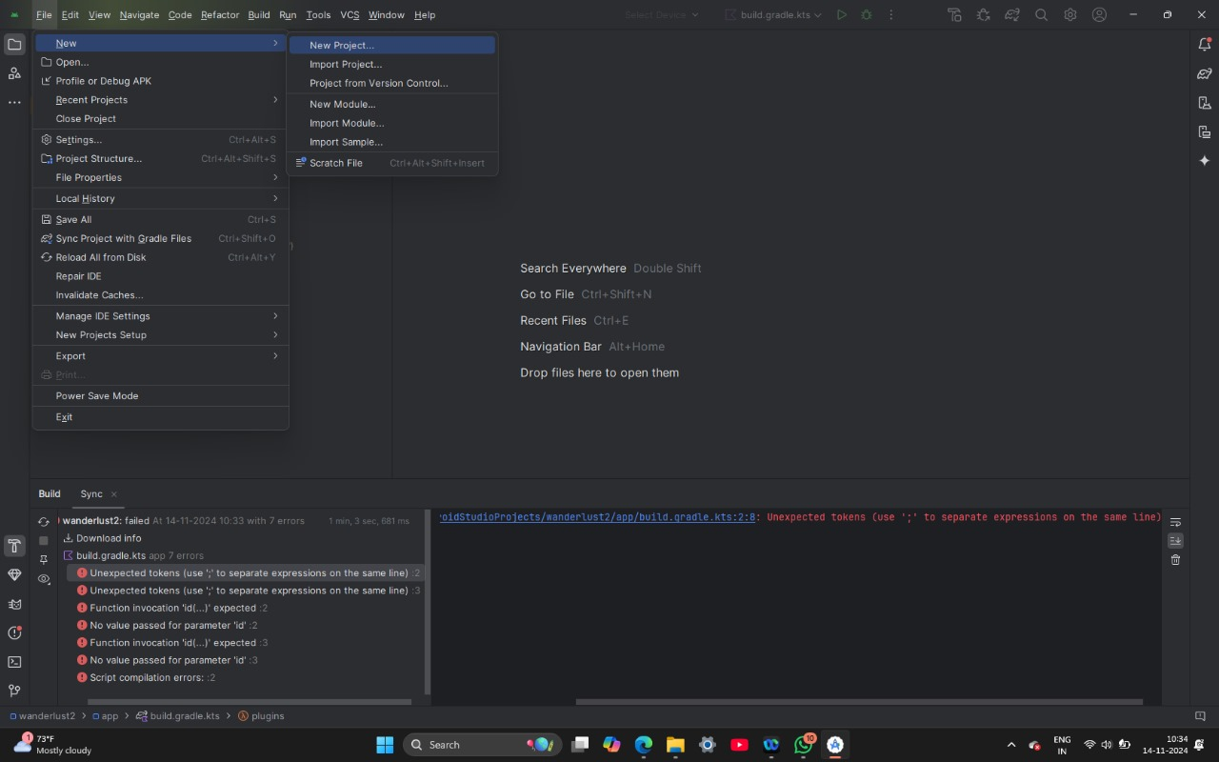

**Step :2**

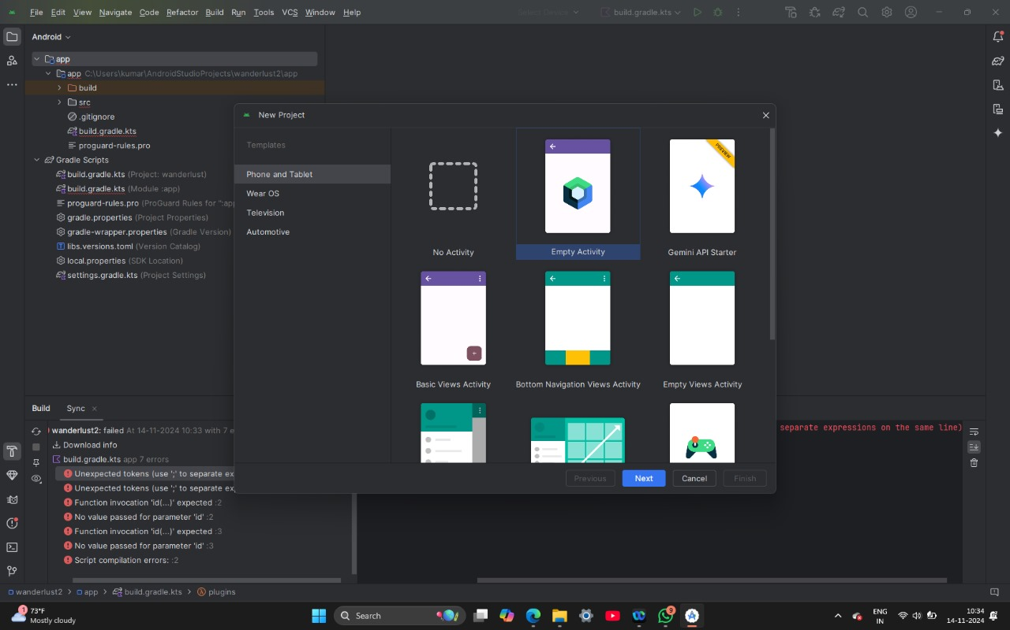

**Step :3**

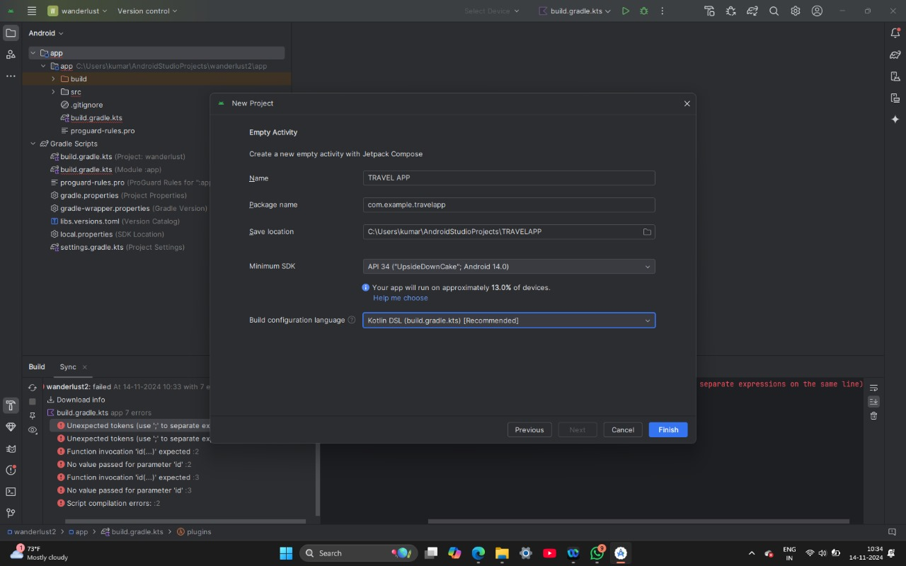

**Step :4**

